Putu Andika Tedja Permana

180030302

BA183

**Tugas Data Visualization**

**Bukti Screenshot Sudah Install Python**

Versi Python melalui command prompt

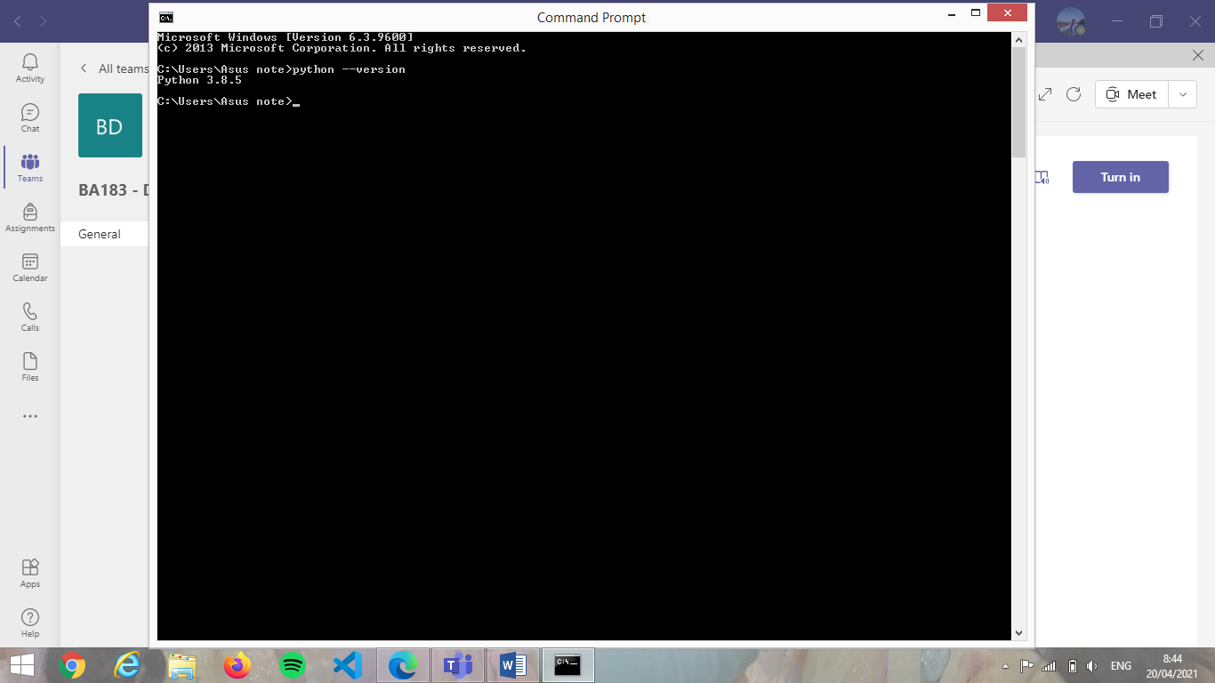

Screenshot IDLE Python

